A Medium's Halloween

Becky Tibbs: A North Carolina Medium's Mystery Series, Book 15

Chariss K. Walker
Disclaimer
This is a work of fiction. Names, characters, businesses, places, events, and incidents are either the product of the author's imagination or used in a fictitious manner. Any resemblance to actual persons, living or dead, or actual events is purely coincidental.
All rights reserved. No part of this book may be reproduced or transmitted in any form or by any means, electronic or mechanical, including photocopying, recording, or by any information storage and retrieval system, without written permission from the author.

Check out all the books in this series here: Becky Tibbs: A North Carolina Medium's Mystery Series:

Copyright © 2022 Chariss K. Walker
All rights reserved.
ASIN:
ISBN:

Get an awesome free book when you subscribe to my newsletter!

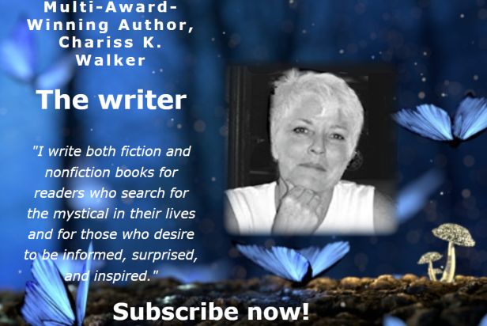

“When people are like, 'Life is good,' I go, 'No, life is a series of disastrous moments, painful moments, unexpected moments, and things that will break your heart. And in between those moments, that's when you savor, savor, savor.'”
”
.~~Sandra Bullock

Contents
Chapter 1

Chapter 1
Becky Tibbs arrived at her antique store in the popular River Arts District early on Labor Day morning. She immediately greeted the three helper ghosts, Jacob, Lois, and Myrtle but it was difficult to pay much attention to their chatter when she had a lot on her mind.
She was excited about the Grand Opening Extravaganza planned for that day. Becky and Sally had stayed late the night before to decorate for the celebration of her new ownership and the renaming of her store.
Once, simply known as Antiques, the store was now The River Arts District Antique Store, and

